

**Faculty of engineering - Shoubra**

**Benha University**

**Research Article / Research Project / Literature Review**

in fulfillment of the requirements of

|  |  |
| --- | --- |
| **Department** | **Engineering Mathematics and Physics** |
| **Division** | **-----------------** |
| **Academic Year** | **2019-2020 Preparatory** |
| **Course name** | **Computer** |
| **Course code** | **ECE006** |

**Title: -**

Internet of things

By:

|  |  |  |  |
| --- | --- | --- | --- |
|  | Name | Edu mail | B.N |
| 1 | Gehad Ahmed Hussein Ahmed Elwan | [gehad195297@feng.bu.edu.eg](mailto:gehad195297@feng.bu.edu.eg) | 269 |

**Approved by:**

|  |  |
| --- | --- |
| Examiners committee | Signature |
| Dr. Ahmed Bayoumi |  |
| Dr. Shady Elmashad |  |
| Dr. Abdelhamid Attaby |  |

# Application brief:

# What is internet of things (IoT)

# The internet of things, or IoT, is a system of interrelated computing devices, mechanical and digital machines, objects, animals or people that are provided with unique identifiers ([UIDs](https://internetofthingsagenda.techtarget.com/definition/unique-identifier-UID)) and the ability to transfer data over a network without requiring human-to-human or human-to-computer interaction.

## **IoT Applications**

## **Wearables:** Wearable technology is a hallmark of IoT applications and probably is one of the earliest industries to have deployed the IoT at its service. We happen to see Fit Bits, heart rate monitors and smartwatches everywhere these days.

1. Smart Home Applications: When we talk about IoT Applications, Smart Homes are probably the first thing that we think of. The best example I can think of here is Jarvis, the AI home automation employed by Mark Zuckerberg.
2. **Health Care:** oT applications can turn reactive medical-based systems into proactive wellness-based systems.The resources that current medical research uses, lack critical real-world information. It mostly uses leftover data, controlled environments, and volunteers for medical examination. IoT opens ways to a sea of valuable data through analysis, real-time field data, and testing.

## **Smart Cities:** By now I assume, most of you must have heard about the term **Smart City**. The hypothesis of the optimized traffic system I mentioned earlier, is one of the many aspects that constitute a smart city.

## **Agriculture:** Statistics estimate the ever-growing world population to reach nearly 10 billion by the year 2050. To feed such a massive population one needs to marry agriculture to technology and obtain best results. There are numerous possibilities in this field. One of them is the **Smart Greenhouse**.

## **Industrial Automation:** This is one of the fields where both faster developments, as well as the quality of products, are the critical factors for a higher Return on Investment. With IoT Applications, one could even re-engineer products and their packaging to deliver better performance in both cost and customer experience. IoT here can prove to be game changing with solutions for all the following domains in its arsenal.

Screenshots:

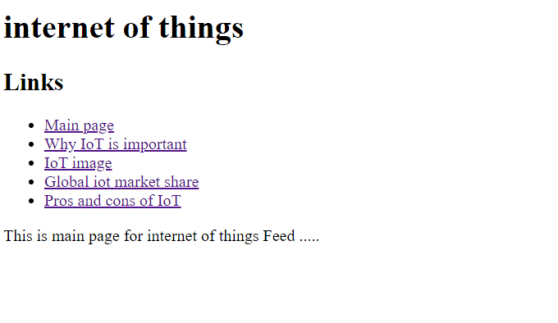

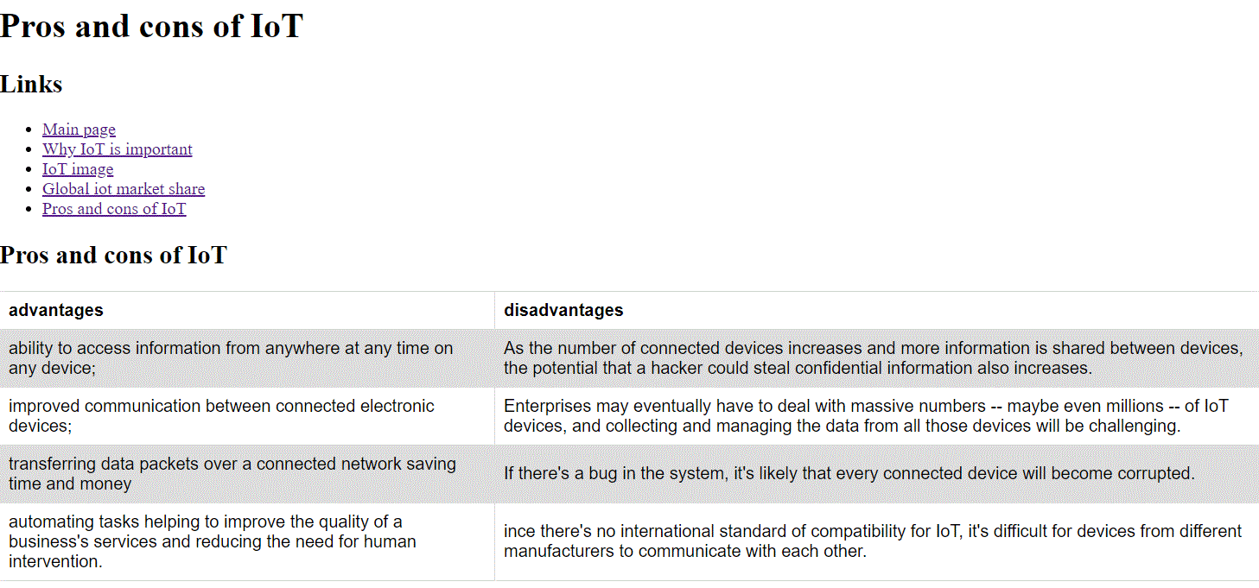

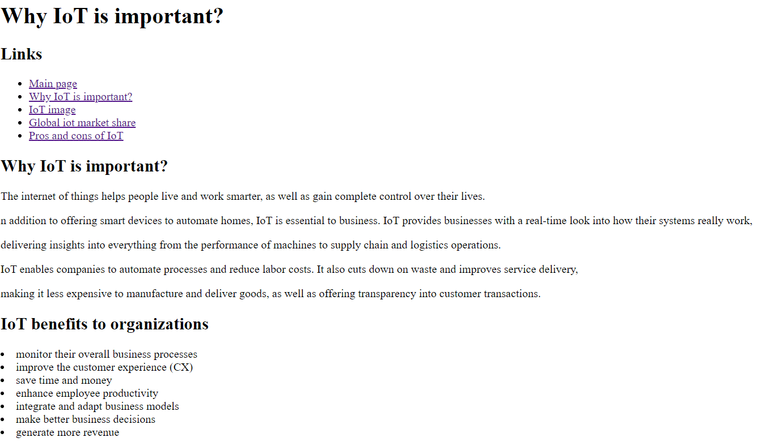

# Source code:

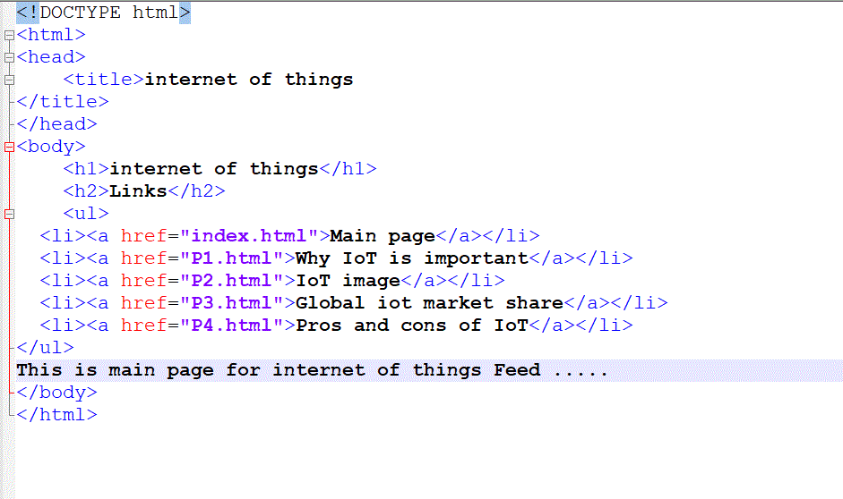

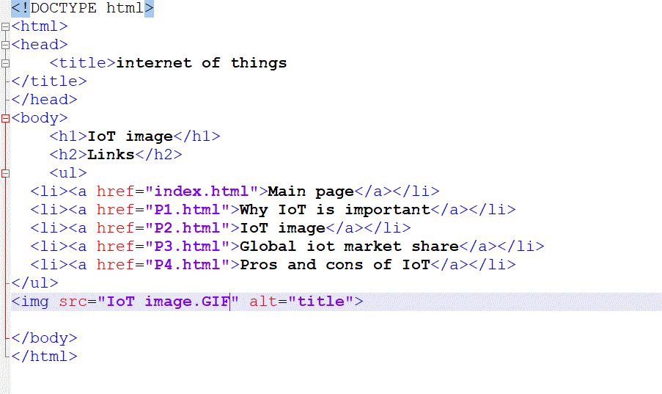

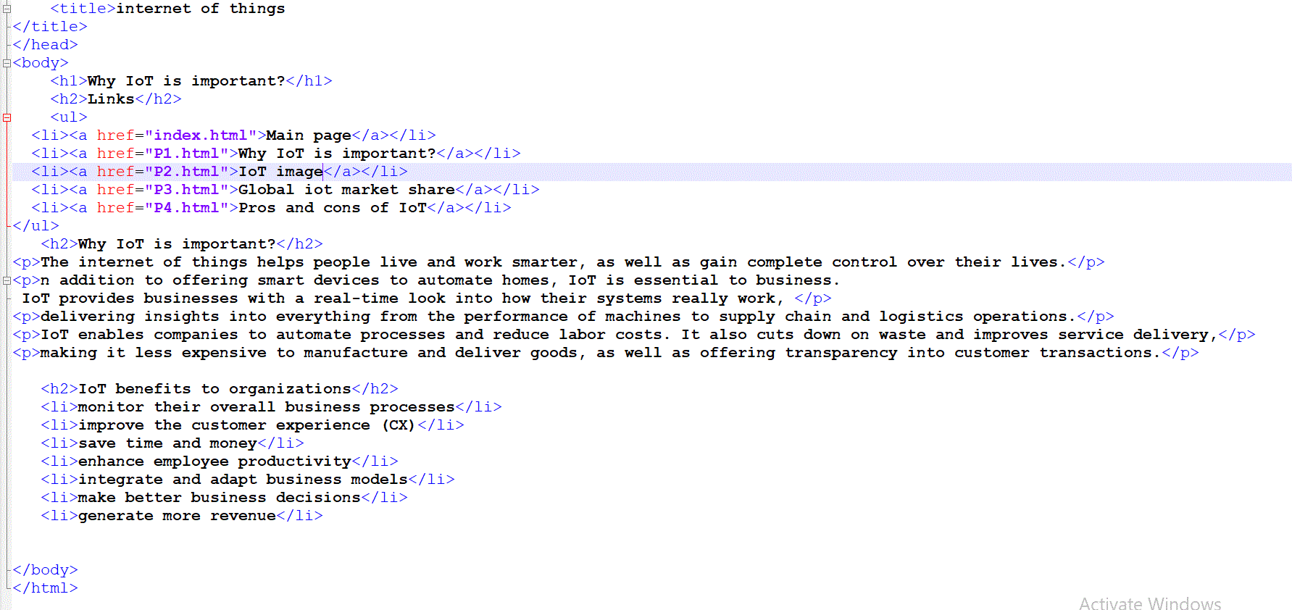

**References**

* <https://internetofthingsagenda.techtarget.com/definition/Internet-of-Things-IoT>
* <https://justcreative.com/2018/11/19/internet-of-things-explained/>
* <https://www.edureka.co/blog/iot-applications/>